From page 19:
The Life of Peter D. Smith
When Jesus the Healer Passed Through Galilee is the product of travel, reflection, and a love of the folk-song tradition. Its author, songwriter and minister, Peter D. Smith, was born in 1938 in Weybridge, England, a town in the southeast county of Surrey. Dual passions for music and travel emerged early in his life. Educated at Farnham Grammar School, Smith studied piano as a boy and adored classical music, which earned him the playground nickname "Mozart Smith." As he grew older, Smith was drawn to the widely popular skiffle style of folk music. Skiffle has its roots in early twentieth-century African American music and is characterized by the blending of traditional band instruments such as bass and guitar with cigar-box fiddles, wax-paper harmonicas, and washboard percussion. Smith, a guitarist, discovered in the playful, tongue-in-cheek skiffle style a doorway to folk music as a powerful means of expression.
Acquiring a battered second-hand guitar, Smith taught himself to play finger-style and performed often with friends. As a young man, Smith completed a five-year apprenticeship in the aircraft industry, but abandoned this course in favor of seminary. He began his studies at Richmond Theological College in Surrey and completed them at Birmingham. Smith served a year at a Liverpool Mission near the Bootle Docks, an area which had been heavily hit by the blitzes of the Second World War. In this way, Smith's career path begins to reflect that of Reverend George Macleod, who founded the modern-day Iona community. Smith eventually led courses on contemporary worship for the Iona community. He acquired a new nickname: "The Singing Minister from the Mission."
Smith began to travel extensively, guitar in hand, connecting with people in different parts of the world and learning their song. He visited Canada, the United States, Mexico, Turkey, and Greece, and spent a period living with a peasant community on the island of Crete. As his repertoire of folk songs grew, Smith compiled them in to a trilogy of collections: Faith, Folk and Clarity (1968), Faith, Folk and Nativity (1969), and Faith, Folk and Festivity (1969). Smith's belief in folk song's unique power to express the people's praise and prayer is evident in these diverse collections.
His songbooks include African-American spirituals, folk songs from Israel, Mexico and England, and contemporary compositions by Sydney Carter and others. Smith included songs that use immediate, contemporary language to make their point. "Come Down Lord From Your Heaven (A Soho De Profundis)" by Judith Piepe, a selection from Faith, Folk and Clarity, acknowledges Christ's descent into hell and expresses how the modern-day oppressed can relate to his suffering in the ravages of drug addiction, poverty, and injustice. "So come down, Lord, from your heaven, if what they say is true;" writes Piepe, "come down into this den of thieves, there's thieves have need of you." In his introduction to Faith, Folk and Clarity, Smith expresses that he believes folk music, "with its roots in the people, its disregard for the party line, its refusal to court low commercial standards, its simplicity and tradition, and its association with many of the great religious and humanitarian movements...is proving an excellent medium for expressing Christian faith and concern."

From page 22:
Guitar Guidance: When Jesus the Healer Passed Through Galilee
Playing the melody with chords in classical guitar style (often called "finger style" in non-classical repertoire), presents similar challenges in the key of F. Not only are barre chords always needed (the index finger of the left hand pressing multiple strings at the same time), but F major is also a less resonant key on the guitar. Many players, therefore, opt for a capo at the first fret, and play in the key of E. Here's one way to play it:
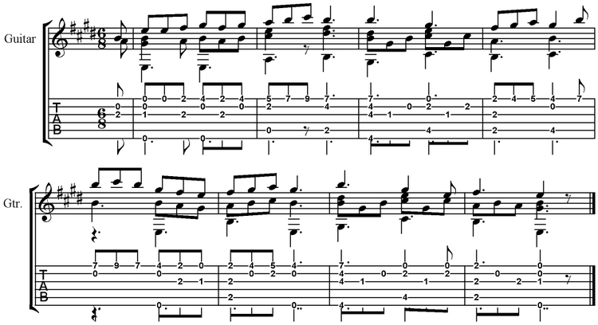
Another way to play the melody, this time without a capo, is to place it in the bass range, playing it with the thumb. This gives it a more folk-like country flavor, one in complete character with the tune. Work out your own arrangement, but think about beginning this way:
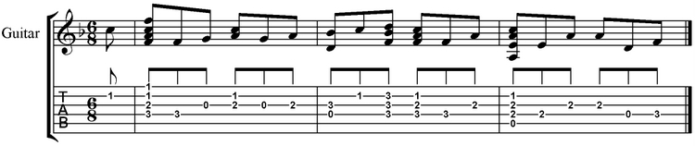

Hymnary.org
Do you search for hymns and worship music for worship services? Are you researching a particular hymn? Are you looking for an arrangement or media file? If so, Hymnary.org is a perfect resource for you. Hymnary.org is a searchable database of hymnals and worship resources which aims to be the world's most comprehensive database of North American hymnody. This online hymn and worship music database is ideal for worship leaders, hymnologists, and amateur hymn lovers alike. At www.hymnary.org hymns are searchable by title, tune, meter, key, scripture reference, and more.
A search for "Smith, Peter" brings up When Jesus the Healer Passed Through Galilee. A topic search for the word "healing" brings up this song as well, along with many other hymns appropriate for Lent and beyond. Using "My Hymnals," you can set up a list of hymnals that you own and search only for resources that are available on your shelf.
Visit www.hymnary.org.

